**Lesson 4: The Precise Definition of a Limit**

After completing this lesson, you should be able to

* discuss finite limits
* discuss infinite limits
* discuss finite limits at infinity

**Commentary**

**Topics**

1. [Finite Limits](https://content.umuc.edu/file/7bdece95-b196-4233-9313-aa904663b08e/1/MATH140-0909.zip/Modules/M2-Module_2/Lesson_4/S3-Commentary.html#I)
2. [Infinite Limits](https://content.umuc.edu/file/7bdece95-b196-4233-9313-aa904663b08e/1/MATH140-0909.zip/Modules/M2-Module_2/Lesson_4/S3-Commentary.html#II)
3. [Finite Limits at Infinity](https://content.umuc.edu/file/7bdece95-b196-4233-9313-aa904663b08e/1/MATH140-0909.zip/Modules/M2-Module_2/Lesson_4/S3-Commentary.html#III)

**1. Finite Limits**

In lesson 2, we approached the limit concept using an informal definition. In this lesson, we will make the definition more precise. As we observed in Exercise 2.2.5, the informal definition for limits is not sufficient to help us determine the following limit with certainty:

https://content.umuc.edu/file/7bdece95-b196-4233-9313-aa904663b08e/1/MATH140-0909.zip/Modules/M2-Module_2/Lesson_4/images/finite-limit-eq.gif

In order to prove https://content.umuc.edu/file/7bdece95-b196-4233-9313-aa904663b08e/1/MATH140-0909.zip/Modules/M2-Module_2/Lesson_4/images/finite-limit-eq.gif(and many other limit problems), we need to come up with a better definition for limits. We need to replace phrases such as "as *x* gets closer to *c*" and "*f*(*x*) becomes nearer to the limit *L*" with more formal mathematical language.

Consider the following exercise for insight into how a more precise definition can be helpful.

**Exercise 2.4.1: Work Toward a Better Limit Definition**

**Problem**

Suppose https://content.umuc.edu/file/7bdece95-b196-4233-9313-aa904663b08e/1/MATH140-0909.zip/Modules/M2-Module_2/Lesson_4/images/Math140-mo2-lessn4-ex2-4-1-prob.gif How close to *c* = 2 must *x* be in order for *g*(*x*) to differ from 8 by less than 0.001?

**Solution**

When *x* is close to 2, *g*(*x*) is close to 8, and so https://content.umuc.edu/file/7bdece95-b196-4233-9313-aa904663b08e/1/MATH140-0909.zip/Modules/M2-Module_2/Lesson_4/images/limit-x-to-2.gif*g*(*x*) = 8.

Symbolically, we write the distance from *x* to 2 as |*x* – 2|, and the distance from *g*(*x*) to 8 as |*g*(*x*) – 8|.

To solve this problem, we need to find a number δ (Greek lower-case letter*delta*) so that if *x* is within units of 2, then*g*(*x*) is within 0.001 units of the limit value, 8. We can write this symbolically:

if |*x* – 2| < δ, then |*g*(*x*) – 8| < 0.001

To find the number δ, we begin with the following:

|*g*(*x*) – 8| < 0.001  
|(3*x* + 2) – 8| < 0.001  
|3*x* – 6| < 0.001  
|3(*x* – 2)| < 0.001  
3|*x* – 2| < 0.001  
|*x* – 2| < (0.001)/3  
|*x* – 2| < 0.0003

This means that if |*x* – 2| < 0.0003, then |*g*(*x*) – 8| < 0.001. Thus, we can say definitively that if the distance between *x* and 2 is less than 0.001, the limit value, 8, will be within 0.0003 units of *g*(*x*). That is, for values of *x* in the open interval (1.9997, 2.0003), values of *f*(*x*) will lie in the open interval (7.999, 8.001).

As you can see, this kind of information can be useful when you are asked to find a particular value to a particular degree of accuracy.

Figure 2.4.1 shows that if the distance between *x* and 2 is within 0.001, then the limit value 8 will be within 0.0003 units of *g*(*x*).

**Figure 2.4.1  
If |*x* – 2| < 0.001, Then |*g*(*x*) – 8| < 0.0003**

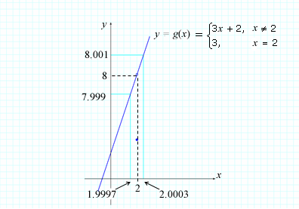

**Note This**

|  |  |
| --- | --- |
| https://content.umuc.edu/file/7bdece95-b196-4233-9313-aa904663b08e/1/MATH140-0909.zip/Modules/M2-Module_2/Lesson_4/images/NoteThisIcon.png | We call the number 0.001 the **error tolerance** for *g*(*x*), as it gives us an indication of how close we can get to the value(s) of*g*(*x*) for a particular proximity to the value for *x*. |

In the exercise above, we required an error tolerance of 0.001; however, in order to be precise in our limit statement, *https://content.umuc.edu/file/7bdece95-b196-4233-9313-aa904663b08e/1/MATH140-0909.zip/Modules/M2-Module_2/Lesson_4/images/limit-x-to-2.gifg*(*x*) = 8, we need to require that the difference between *g*(*x*) and the limit value 8 be less than *any positive number* (not just less than 0.001). We can accomplish this using the approach illustrated in the exercise above, replacing the error tolerance of 0.001 with an arbitrarily small positive number ε (Greek lower-case letter *epsilon*).

(*)if |*x* – 2| < δ = ε/3, then |*g*(*x*) – 8| < ε

This is how we can precisely state that *g*(*x*) is arbitrarily close to 8 if *x* is sufficiently close to 2. That is, by considering values of *x* that are a very small positive distance (δ = ε/3 > 0) from 2, we can make the values of *g*(*x*) a very small positive distance (ε > 0) from 8.

We can write (*), which is visually represented in figure 2.4.2, as follows:

if –δ < *x* – 2 < δ, then –ε < *g*(*x*) – 8 < ε

if 2 – δ < *x* < 2 + δ, then 8 – ε < *g*(*x*) < 8 + ε

**Figure 2.4.2  
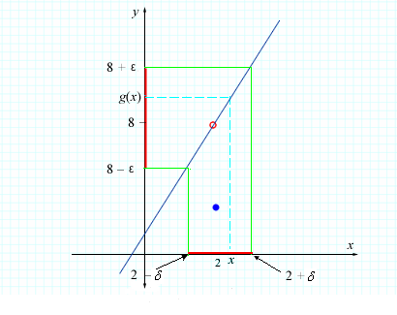**

We are now ready to write a precise definition of a limit.

Definition 9: Finite Limit

Suppose *f*(*x*) is a function defined on an open interval that contains a number *c*, except possibly *c* itself. We say that the limit of *f*(*x*) as *x* approaches *c* is *L*, and write

https://content.umuc.edu/file/7bdece95-b196-4233-9313-aa904663b08e/1/MATH140-0909.zip/Modules/M2-Module_2/Lesson_4/images/Definition9.gif

if for every number ε > 0 there exists a number δ > 0 such that

|*f*(*x*) – *L*| < ε IF 0 < |*x* – c| < δ

This definition tells us that, for any number ε > 0 as small as we like, there is a corresponding number δ > 0 such that if *x* lies within the open interval (*c* – δ, *c* + δ) with *x* ≠ *c*, then *f*(*x*) will be in the open interval (*L*– ε, *L* + ε). In other words, we can make the distance between *f*(*x*) and *L*, |*f*(*x*) – *L*| arbitrarily small by considering the distance between *x* and *c*, |*x* – *c*| to be sufficiently small positive.

In the precise definition for a limit, we emphasize that the choice of ε > 0 is arbitrary, and therefore, that the method for finding the corresponding δ must work for any number ε regardless of how small positive ε is. Figures 2.4.3a and 2.4.3b show how the choice of a smaller ε > 0 can result in a smaller δ > 0.

|  |  |
| --- | --- |
| **Figure 2.4.3a Precise Definition of a Limit** | **Figure 2.4.3b Choosing a Smaller ε > 0 May Result in a Smaller δ > 0** |

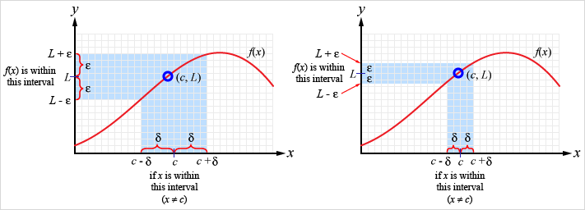

**Note This**

|  |  |
| --- | --- |
| https://content.umuc.edu/file/7bdece95-b196-4233-9313-aa904663b08e/1/MATH140-0909.zip/Modules/M2-Module_2/Lesson_4/images/NoteThisIcon.png | A useful strategy to employ when proving a limit (using ε and δ) is to first find a value for δ and to then confirm that the value works (see Exercise 2.4.2 below). |

**Exercise 2.4.2: Prove a Limit Equation I**

**Problem**

Prove https://content.umuc.edu/file/7bdece95-b196-4233-9313-aa904663b08e/1/MATH140-0909.zip/Modules/M2-Module_2/Lesson_4/images/limit-x-to-1.gif(5*x* – 3) = 2.

**Solution, Part I**

First, we find a value for δ.

We need to show that for every ε > 0, there exists a δ > 0 such that

|*f*(*x*) – *L*| < ε IF 0 < |*x* – *c*| < δ

In particular, we need to show that for every ε > 0, there exists a δ > 0 such that

|(5*x* – 3) – 2| < ε IF |*x* – 1| < δ

And because |(5*x* – 3) – 2| = |5*x* – 5| = |5(*x* – 1)| = 5|*x* – 1|, we need show that for every ε > 0, there exists a δ > 0 such that

5|*x* – 1| < ε IF |*x* – 1| < δ

OR

|*x* – 1| < ε/5 IF |*x* – 1| < δ

suggesting that the candidate for δ in terms of ε is δ = ε/5.

**Solution, Part II**

Next, we confirm that the value for δ works.

To confirm that the δ candidate is valid for a given ε > 0, we choose δ = ε/5 and assume that 0 < |*x* – 1| < δ. Then, we consider |(5*x* – 3) – 2| = |5*x* – 5| = 5|*x* – 1| < 5δ = 5(ε/5) = ε.

If 0 < |*x* – 1| < δ, then |(5*x* – 3) – 2| < ε. This proves by the definition that

https://content.umuc.edu/file/7bdece95-b196-4233-9313-aa904663b08e/1/MATH140-0909.zip/Modules/M2-Module_2/Lesson_4/images/Math140-mo2-lessn4-ex2-4-2-soltn-pt2.gif

https://content.umuc.edu/file/7bdece95-b196-4233-9313-aa904663b08e/1/MATH140-0909.zip/Modules/M2-Module_2/Lesson_4/images/Math140-mo2-lessn4-ex2-4-4-figtitle.gif

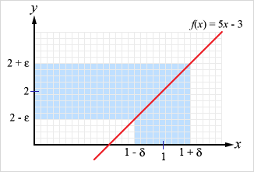

The limit of *f*(*x*) as *x* approaches 1 is 2.

In lesson 2, we provided informal definitions for one-sided limits; now, we can provide more precise definitions for both the right-side and the left-side limit.

Definition 10: Right-Side Limit

Suppose *f*(*x*) is a function defined on an open interval that contains a number *c*, except possibly *c* itself. We say that the **right-side limit** of *f*(*x*) as *x*approaches *c* is *L*, and write

https://content.umuc.edu/file/7bdece95-b196-4233-9313-aa904663b08e/1/MATH140-0909.zip/Modules/M2-Module_2/Lesson_4/images/Definition10a.gif

if for every number ε > 0, there exists a number δ > 0 such that

|*f*(*x*) – *L*| < ε IF 0 < *x* – *c* < δ

Alternatively, we can readhttps://content.umuc.edu/file/7bdece95-b196-4233-9313-aa904663b08e/1/MATH140-0909.zip/Modules/M2-Module_2/Lesson_4/images/limit-x-to-c-plus.gif *f*(*x*) = *L*: the limit of *f*(*x*) as *x* approaches *c*from the right is *L*.

Definition 11: Left-Side Limit

Suppose *f*(*x*) is a function defined on an open interval that contains a number *c*, except possibly *c* itself. We say that the**left-side limit**of *f*(*x*) as *x*approaches *c* is *L*, and write

https://content.umuc.edu/file/7bdece95-b196-4233-9313-aa904663b08e/1/MATH140-0909.zip/Modules/M2-Module_2/Lesson_4/images/Definition10b.gif

if for every number ε > 0, there exists a number δ > 0 such that

|*f*(*x*) – *L*| < ε IF –δ < *x* –*c* < 0

Alternatively, we can read https://content.umuc.edu/file/7bdece95-b196-4233-9313-aa904663b08e/1/MATH140-0909.zip/Modules/M2-Module_2/Lesson_4/images/limit-x-to-c-minus.gif *f*(*x*) = *L*: the limit of *f*(*x*) as *x* approaches *c* from the left is *L*.

**Note This**

|  |  |
| --- | --- |
| https://content.umuc.edu/file/7bdece95-b196-4233-9313-aa904663b08e/1/MATH140-0909.zip/Modules/M2-Module_2/Lesson_4/images/NoteThisIcon.png | The definition for the right-side limit is the same as the precise definition for a limit, except that *x* must be in the right half of the interval (*c* – δ, *c* + δ), namely, in (*c*, *c*+ δ). Similarly, the definition for the left-side limit is the same as the precise definition for a limit, except that *x* must be in the left half of the interval (*c* – δ, *c* + δ), namely, in (*c*– δ, *c*). |

**Exercise 2.4.3: Prove a Limit Equation II**

**Problem**

Prove https://content.umuc.edu/file/7bdece95-b196-4233-9313-aa904663b08e/1/MATH140-0909.zip/Modules/M2-Module_2/Lesson_4/images/Math140-mo2-lessn4-ex2-4-3-prob.gif.

**Solution, Part I**

First, we graph and label the function.

**https://content.umuc.edu/file/7bdece95-b196-4233-9313-aa904663b08e/1/MATH140-0909.zip/Modules/M2-Module_2/Lesson_4/images/Math140-mo2-lessn4-ex2-4-5-figtitle.gif**

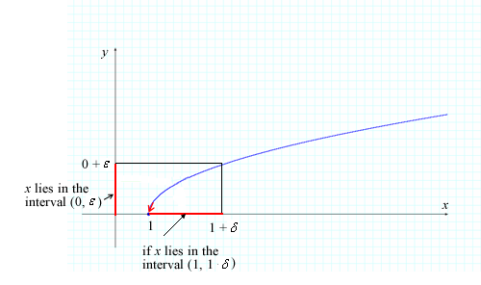

**Solution, Part II**

Next, we find a value for δ.

According to the limit definitions, we need to show that for every ε > 0, there exists a δ > 0 such that

|*f*(*x*) – *L*| < ε IF 0 < *x* –*c*< δ

Let ε > 0 be given with *c*= 1, *L* = 0; we need to find δ > 0 such that

https://content.umuc.edu/file/7bdece95-b196-4233-9313-aa904663b08e/1/MATH140-0909.zip/Modules/M2-Module_2/Lesson_4/images/Math140-mo2-lessn4-ex2-4-5-prob3a.gif

https://content.umuc.edu/file/7bdece95-b196-4233-9313-aa904663b08e/1/MATH140-0909.zip/Modules/M2-Module_2/Lesson_4/images/Math140-mo2-lessn4-ex2-4-5-prob3b.gif

https://content.umuc.edu/file/7bdece95-b196-4233-9313-aa904663b08e/1/MATH140-0909.zip/Modules/M2-Module_2/Lesson_4/images/Math140-mo2-lessn4-ex2-4-5-prob3c.gif

Hence, we choose the candidate δ = ε2.

**Solution, Part III**

Next, we confirm that the choice for δ works.

Let ε > 0 be given with *c* = 1, *L* = 0; we choose δ = ε2 and assume 0 < *x* – 1 < δ. Then, we consider

https://content.umuc.edu/file/7bdece95-b196-4233-9313-aa904663b08e/1/MATH140-0909.zip/Modules/M2-Module_2/Lesson_4/images/Math140-mo2-lessn4-ex2-4-4-soltn-pt3.gif

Thus, if 0 < *x* – 1 < δ, then https://content.umuc.edu/file/7bdece95-b196-4233-9313-aa904663b08e/1/MATH140-0909.zip/Modules/M2-Module_2/Lesson_4/images/Math140-mo2-lessn4-ex2-4-5-prob3.gif. This proves, according to Definition 10,

https://content.umuc.edu/file/7bdece95-b196-4233-9313-aa904663b08e/1/MATH140-0909.zip/Modules/M2-Module_2/Lesson_4/images/Math140-mo2-lessn4-ex2-4-3-prob.gif (see figure 2.4.5 above)

**Exercise 2.4.4: Prove a Limit Equation III**

**Problem**

Prove https://content.umuc.edu/file/7bdece95-b196-4233-9313-aa904663b08e/1/MATH140-0909.zip/Modules/M2-Module_2/Lesson_4/images/Math140-mo2-lessn4-ex2-4-4-prob.gif.

**Solution, Part I**

First, we find a value for δ. According to the limit definitions, we need to show that for every ε > 0, there exists a δ > 0 such that

|*x*2 – 25| < ε IF 0 < |*x* – 5| < δ

⇒|(*x* – 5)(*x* + 5)| < ε IF 0 < |*x* – 5| < δ

 ⇒|*x* – 5||*x* + 5| < ε IF 0 < |*x* – 5| < δ(1)

In order to move forward, we must bound the factor |*x* + 5| (which is not connected to the factor associated with |*x* – c| = |*x* – 5|).

We choose a convenient restriction on δ (typically, δ ≤ 1, although any restriction on the form δ ≤ *k*, where *k* is a constant, will suffice).

By choosing the restriction δ ≤ 1, we obtain

0 < |*x* – 5| < δ ⇒ 0 < |*x* – 5| < 1

 ⇒ –1 < *x* – 5 < 1 ⇒ 9 < *x* + 5 < 11

and so |*x* + 5| < 11.

If δ ≤ 1 and 0 < |*x* – 5| < δ, then

|*x* – 5||*x* + 5| < 11δ

This suggests that we have two choices for δ, namely, 1 and https://content.umuc.edu/file/7bdece95-b196-4233-9313-aa904663b08e/1/MATH140-0909.zip/Modules/M2-Module_2/Lesson_4/images/epsilon-ovr-11.gif. To ensure that we choose the best candidate for δ, we pick the smaller of the two numbers; we write this mathematically as δ = minhttps://content.umuc.edu/file/7bdece95-b196-4233-9313-aa904663b08e/1/MATH140-0909.zip/Modules/M2-Module_2/Lesson_4/images/Math140-mo2-lessn4-fig2-4-4-soltn-part1.gif.

**Solution, Part II**

Next, we confirm that the choice for δ = minhttps://content.umuc.edu/file/7bdece95-b196-4233-9313-aa904663b08e/1/MATH140-0909.zip/Modules/M2-Module_2/Lesson_4/images/Math140-mo2-lessn4-fig2-4-4-soltn-part1.gifworks.

Let ε > 0 be given *c* = 5, *L* = 25. We choose δ =  minhttps://content.umuc.edu/file/7bdece95-b196-4233-9313-aa904663b08e/1/MATH140-0909.zip/Modules/M2-Module_2/Lesson_4/images/Math140-mo2-lessn4-fig2-4-4-soltn-part1.gif, and assume 0 < |*x* – 5| < δ. From Part I of the solution,

0 < |*x* – 5| < 1 ⇒ –1 < *x* – 5 < 1 ⇒ 9 < *x* + 5 < 11 ⇒ |*x* + 5| < 11

We also have from Part I |*x* – 5| < https://content.umuc.edu/file/7bdece95-b196-4233-9313-aa904663b08e/1/MATH140-0909.zip/Modules/M2-Module_2/Lesson_4/images/epsilon-ovr-11.gif, and so

|*x*2 – 25| = |*x* – 5||*x* + 5| < https://content.umuc.edu/file/7bdece95-b196-4233-9313-aa904663b08e/1/MATH140-0909.zip/Modules/M2-Module_2/Lesson_4/images/epsilon-ovr-11.gif • 11 = ε

This proves *https://content.umuc.edu/file/7bdece95-b196-4233-9313-aa904663b08e/1/MATH140-0909.zip/Modules/M2-Module_2/Lesson_4/images/limit-x-to-5.gifx*2 = 25.

As you may suspect from our work in the exercise above, proving limits using the ε – δ method can be fairly involved and is not always practical. Because the Limit Principles given in lesson 3 can be proven using the ε – δ method, we can turn to these principles as a rigorous alternative to finding more complicated limits without needing an ε – δ proof.

**2. Infinite Limits**

In the precise definition of a limit, we require the value of *f*(*x*) to be arbitrarily close to a finite number *L* for any *x* sufficiently close to *c*. In the precise definition for infinite limits, we require values of *f*(*x*) to become arbitrarily large (larger than any positive number *N*, for example) by considering values of *x* sufficiently close to *c*(but not necessarily equal to *c*). Definitions 12 and 13 are the precise definitions for infinite limits.

Definition 12: Infinite Limits

Suppose *f*(*x*) is a function defined on an open interval that contains a number *c*, except possibly *c* itself. Then, say that **the limit of *f*(*x*) as *x*approaches *c* is infinity**, and write

https://content.umuc.edu/file/7bdece95-b196-4233-9313-aa904663b08e/1/MATH140-0909.zip/Modules/M2-Module_2/Lesson_4/images/limit-x-to-c.gif*f*(*x*) = ∞

if for every number *N* > 0, there exists a number δ > 0 such that

*f*(*x*) > *N* IF 0 < |*x* – *c*| < δ

Definition 12 tells us that we can make values of *f*(*x*) arbitrarily large (larger than any number *N*> 0) by considering values of *x* sufficiently close to*c*but not necessarily equal to *c*. Geometrically, this means that, given any line *y* = *N*, there exists a number δ > 0 such that if *x* ≠ *c* lies in the interval (*c*– δ, *c* + δ), then the part of the graph of *f*(*x*) within that interval (*c* – δ, *c* + δ) lies above *y* = *N*—that is, that *f*(*x*) > *N* (see figure 2.4.6).

**Note This**

|  |  |
| --- | --- |
| https://content.umuc.edu/file/7bdece95-b196-4233-9313-aa904663b08e/1/MATH140-0909.zip/Modules/M2-Module_2/Lesson_4/images/NoteThisIcon.png | In figure 2.4.6, the larger we require *N* to be, the smaller will be the choice of δ. |

**Figure 2.4.6**

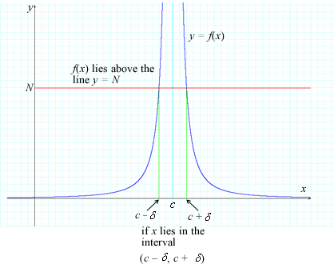

Definition 13: Infinite Limits, Negative Infinity

Suppose *f*(*x*) is a function defined on an open interval that contains a number *c*, except possibly *c* itself. Then, say that **the limit of *f*(*x*) as *x*approaches*c*is negative infinity**, and write

lim(*x*→*c*) *f*(*x*) = –∞

if for every number *N* < 0, there exists a number δ > 0 such that

*f*(*x*) < *N* IF 0 < |*x* – c| < δ

**Figure 2.4.7**

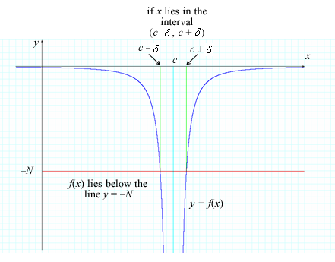

**Exercise 2.4.5: Prove a Limit Equation IV**

**Problem**

Prove https://content.umuc.edu/file/7bdece95-b196-4233-9313-aa904663b08e/1/MATH140-0909.zip/Modules/M2-Module_2/Lesson_4/images/Math140-mo2-lessn4-ex2-4-5-prob.gif.

**Solution, Part I**

First, we find a value for δ.

According to Definition 12, we need to show that for every *N* > 0, there exists a δ > 0 such that

*f*(*x*) > *N* IF 0 < |*x* – c| < δ

Let *N* > 0 be given. We need to find δ > 0 such that

https://content.umuc.edu/file/7bdece95-b196-4233-9313-aa904663b08e/1/MATH140-0909.zip/Modules/M2-Module_2/Lesson_4/images/Math140-mo2-lessn4-ex2-4-5-soltn-a.gif > *N* IF 0 < |*x* – 1| < δ

⇒(*x* – 1)2 < https://content.umuc.edu/file/7bdece95-b196-4233-9313-aa904663b08e/1/MATH140-0909.zip/Modules/M2-Module_2/Lesson_4/images/1-ovr-n.gif IF 0 < | *x* – 1| < δ

⇒(*x* – 1) < https://content.umuc.edu/file/7bdece95-b196-4233-9313-aa904663b08e/1/MATH140-0909.zip/Modules/M2-Module_2/Lesson_4/images/sqrt-1-ovr-N.gif = https://content.umuc.edu/file/7bdece95-b196-4233-9313-aa904663b08e/1/MATH140-0909.zip/Modules/M2-Module_2/Lesson_4/images/1-sqrt-ovr-N.gif IF 0 < |*x* – 1| < δ

Hence, we choose the candidate δ = https://content.umuc.edu/file/7bdece95-b196-4233-9313-aa904663b08e/1/MATH140-0909.zip/Modules/M2-Module_2/Lesson_4/images/sqrt-1-ovr-N.gif.

**Solution, Part II**

Next, we confirm that our choice for δ works.

Let *N* > 0 be given*c*= 1; we choose δ = 1/https://content.umuc.edu/file/7bdece95-b196-4233-9313-aa904663b08e/1/MATH140-0909.zip/Modules/M2-Module_2/Lesson_4/images/sqrt-N.gif and assume 0 < |*x* – 1| < δ.

https://content.umuc.edu/file/7bdece95-b196-4233-9313-aa904663b08e/1/MATH140-0909.zip/Modules/M2-Module_2/Lesson_4/images/Math140-mo2-lessn4-ex2-4-5-prob-lmtdeq-part2.gif

Thus, according to Definition 12, https://content.umuc.edu/file/7bdece95-b196-4233-9313-aa904663b08e/1/MATH140-0909.zip/Modules/M2-Module_2/Lesson_4/images/Math140-mo2-lessn4-ex2-4-5-prob.gif.

**3. Finite Limits at Infinity**

Recall that, in lesson 2, we numerically and geometrically explored limits of the form

https://content.umuc.edu/file/7bdece95-b196-4233-9313-aa904663b08e/1/MATH140-0909.zip/Modules/M2-Module_2/Lesson_4/images/limit-x-to-infinity.gif *f*(*x*) =*A* AND https://content.umuc.edu/file/7bdece95-b196-4233-9313-aa904663b08e/1/MATH140-0909.zip/Modules/M2-Module_2/Lesson_4/images/limit-x-to-minus-infinty.gif *f*(*x*) = *A*

In Definition 7 in lesson 3, we described the first limit as indicating that the values of *f*(*x*) become arbitrarily close to the number *A* when we consider *x* sufficiently large positive. The second limit can be described as meaning that the values of *f*(*x*) become arbitrarily close to the number *A* when we consider *x* sufficiently large negative. We are now ready to formally write the definition for finite limits at infinity.

Definition 14: Finite Limit as *x* **→ ∞**

If *f* is defined on an open interval (*c*, ∞), then

https://content.umuc.edu/file/7bdece95-b196-4233-9313-aa904663b08e/1/MATH140-0909.zip/Modules/M2-Module_2/Lesson_4/images/Definition14.gif

if, given any number ε > 0, there exists a corresponding (positive) number *N* such that

|*f*(*x*) – *A*| < ε IF *x* >*N*

**Figure 2.4.8  
|*f*(*x*) – *A*| < ε IF *x* > *N***

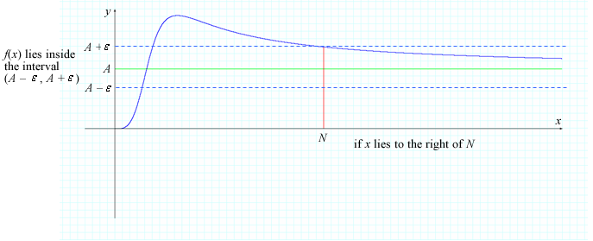

Definition 15: Finite Limit as *x* → –∞

If *f* is defined on an open interval (–∞, *c*), then

https://content.umuc.edu/file/7bdece95-b196-4233-9313-aa904663b08e/1/MATH140-0909.zip/Modules/M2-Module_2/Lesson_4/images/limit-x-to-infinity.gif*f*(*x*) = *A*

if, given any number ε > 0, there exists a corresponding (negative) number *N* such that

|*f*(*x*) – *A*| < ε IF *x* < *N*

**Figure 2.4.9  
|*f*(*x*) – *A*| < ε IF *x* < *N***

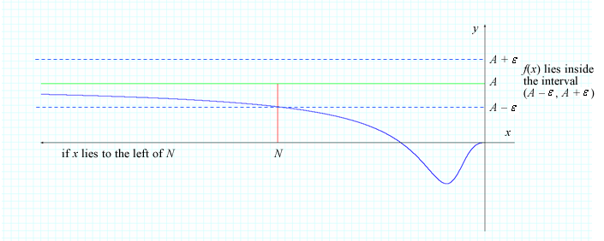

**Exercise 2.4.6: Prove Limit Equations**

**Problem**

Prove the following:

1. https://content.umuc.edu/file/7bdece95-b196-4233-9313-aa904663b08e/1/MATH140-0909.zip/Modules/M2-Module_2/Lesson_4/images/Math140-mo2-lessn4-ex2-4-6a-prob.gif
2. https://content.umuc.edu/file/7bdece95-b196-4233-9313-aa904663b08e/1/MATH140-0909.zip/Modules/M2-Module_2/Lesson_4/images/Math140-mo2-lessn4-ex2-4-6b-prob.gif

**Solution, Part I for Item a**

First, we find a value for *N*. Let ε > 0 be given *f*(*x*) = 1/*x*, and *A*= 0. According to Definition 13, we need to find a number *N* > 0 such that

https://content.umuc.edu/file/7bdece95-b196-4233-9313-aa904663b08e/1/MATH140-0909.zip/Modules/M2-Module_2/Lesson_4/images/Math140-mo2-lessn4-ex2-4-6a-soltn-part1.gif

As we are considering values of *x* → ∞, we can assume *x* > 0 and eliminate the absolute value, giving us

https://content.umuc.edu/file/7bdece95-b196-4233-9313-aa904663b08e/1/MATH140-0909.zip/Modules/M2-Module_2/Lesson_4/images/Math140-mo2-lessn4-ex2-4-6a-soltn-part1a.gif

This suggests that we should choose *N* = 1/ε.

**Solution, Part II for Item a**

Next, we confirm that the choice for*N* works. Let ε > 0 be given *f*(*x*) = 1/*x*, and *L* = 0, and assume *x* > *N*.

Thus,

https://content.umuc.edu/file/7bdece95-b196-4233-9313-aa904663b08e/1/MATH140-0909.zip/Modules/M2-Module_2/Lesson_4/images/Math140-mo2-lessn4-ex2-4-6a-soltn-part2.gif

This proveshttps://content.umuc.edu/file/7bdece95-b196-4233-9313-aa904663b08e/1/MATH140-0909.zip/Modules/M2-Module_2/Lesson_4/images/Math140-mo2-lessn4-ex2-4-6b-prob.gif.

**Solution, Part I for Item b**

First, we find a value for *N*. Let ε > 0 be given *f*(*x*) = 1/*x*, and *A*= 0. According to Definition 15, we need to find a number *N*< 0 such that

https://content.umuc.edu/file/7bdece95-b196-4233-9313-aa904663b08e/1/MATH140-0909.zip/Modules/M2-Module_2/Lesson_4/images/Math140-mo2-lessn4-ex2-4-6b-soltn-part1.gif

That is,

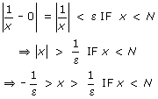

As we are considering values of *x* → –∞, we need only consider values of *x* such that https://content.umuc.edu/file/7bdece95-b196-4233-9313-aa904663b08e/1/MATH140-0909.zip/Modules/M2-Module_2/Lesson_4/images/Math140-mo2-lessn4-ex2-4-6b-soltn-part1bb.gif.

This suggests that we should choose *N* = –1/ε.

**Solution, Part II for Item b**

Finally, we confirm that the choice for *N* works (see Exercise 2.4.5 above).

[*Return to top of page*](https://content.umuc.edu/file/7bdece95-b196-4233-9313-aa904663b08e/1/MATH140-0909.zip/Modules/M2-Module_2/Lesson_4/S3-Commentary.html#pagetop)

[**Report broken links or any other problems on this page.**](http://help.umuc.edu/)  
  
[**Copyright © by University of Maryland University College.**](https://content.umuc.edu/file/7bdece95-b196-4233-9313-aa904663b08e/1/MATH140-0909.zip/common/copyright.html)